**B2 AUTO/RB – DA/IA – IR – TI/RT**

**English Reinforcement**

**Q2**

**Chapter 3**

**DIFFERENT WAYS TO JOB-HUNT**

**LOOKING FOR A JOB**

**Teachers**: J. De Witte & S. Hayen

**Based on the course material by:**

*Denis Thomas*

*De Witte Justine*

*Hayen Stéphanie*

*Hendrickx Thomas*

*Léglise Florence*

*Nisolle Olivia*

**TABLE OF CONTENTS**

1. Introduction: Things To Bear in Mind
2. Funny CV’s
3. Funny Cover Letters
4. Online Application: the “*Indeed*” Example
5. Final Debate

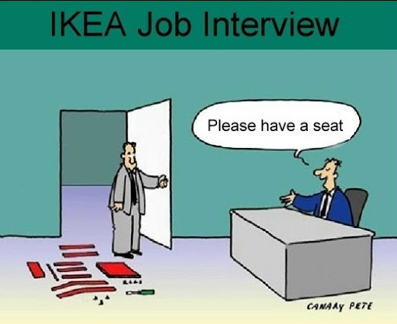

1. **INTRODUCTION: Things To Bear In Mind**

Job hunting involves more than searching for open positions and sending your resume to employers. You also need to make sure you’re a good fit for the job, able to catch the hiring manager’s attention and well-prepared to answer interview questions.

* **Important vocabulary note**: have a look at the table below and fill it in.

|  |  |
| --- | --- |
| **ENGLISH WORD** | **FRENCH TRANSLATION** |
| A CV  🡪 it stands for curriculum vitae | 🡪 ………………………………………………………………. |
| A resume |  |
| A cover(ing) letter |  |

* **“*10 Tips For Job Search Success*”**: read the 10 tips and translate them into French.

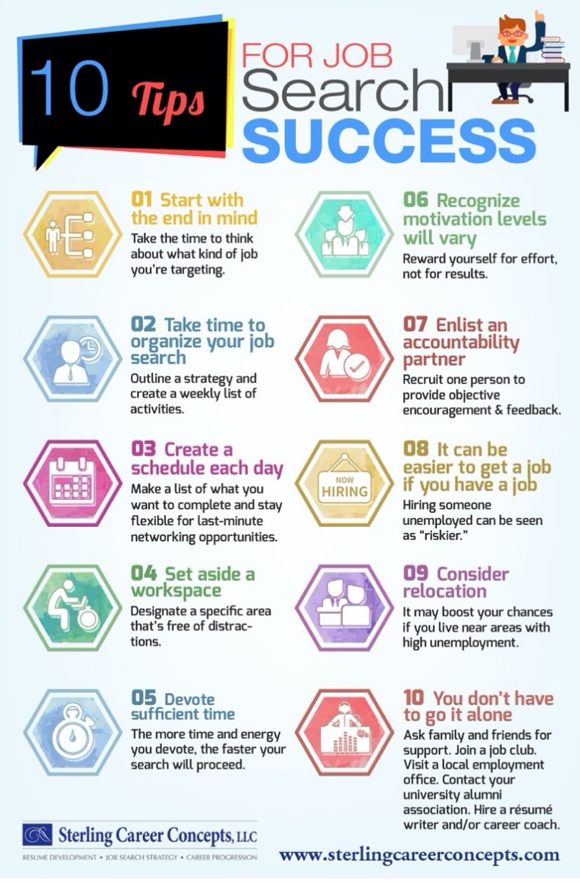

1. Commencer en ayant la fin en tête.
2. Prendre du temps pour organise ses recherches de travail.
3. Créer un planning jour par jour.
4. Désigner un espace de travail.
5. Dédier suffisamment de temps.
6. Être que les niveaux de motivation peuvent ____________.
7. Désigner ____________ pour du feedback.
8. Il peut être plus facile _______________________ si on en a déjà un.
9. Envisager la ____________ (ou un déménagement professionnel »).
10. Vous n’avez pas à faire tout cela ____________
11. **FUNNY CV’s**

Each day hiring managers receive hundreds of applications. So, how can you stand out from the crown and convince them that YOU are the real deal? Try thinking outside of the box and add a humourous touch to your application. In the following two sections, we will take a closer look as to **how to be funny and professional at the same time**.

* **Reading exercise**: read all the CV’s (adapted from: “*The don’ts of funny resumes*”[1]) and match the CV with the most relevant title and description in the table below.

|  |  |
| --- | --- |
| **CV n°** | **TITLE** |
| **1** | The excellent communicator |
| **2** | The drug dealer |
| **3** | **A teen with a good sense of humour** |
| **4** | Probably one of the funniest CV’s |
| **5** | **Simply the best** |
| **6** | The self-loving actor |

|  |  |
| --- | --- |
| The excellent communicator Kudos to his sky-high ego, but apart from being a comedian, he hasn’t demonstrated any transferable skills that will get him hired. | **A teen with a good sense of humour This funny teen actually bagged himself a job at McDonald's with his awesome and honest answers.** |
| The drug dealer This applicant is brutally honest… maybe too honest? It goes from bad to worse, from no education to running a “Marijuana delivery service”. It’s clear he has some sales skills, but not the type you’d want in a professional establishment. | Probably one of the funniest CV’s I mean, who else wouldn’t be impressed with cat-like reflexes, a horse-like laugh and a large appetite?! |
| The self-loving actor Is this really a CV or a hilarious joke? If one picture wasn’t enough, this person decided to share three. The fact that he was cast as a rapist is slightly alarming too! | **Simply the best This devilishly handsome candidate thinks he is the best thing since sliced bread. He’s definitely brave for responding to a job application like this.** |

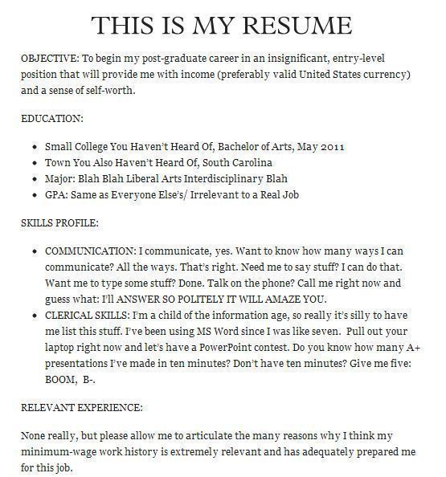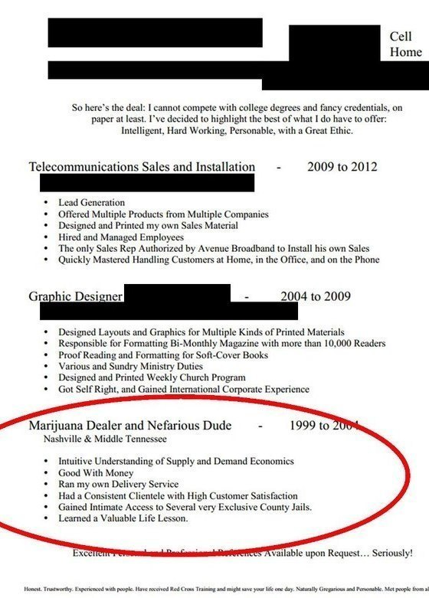

1

2

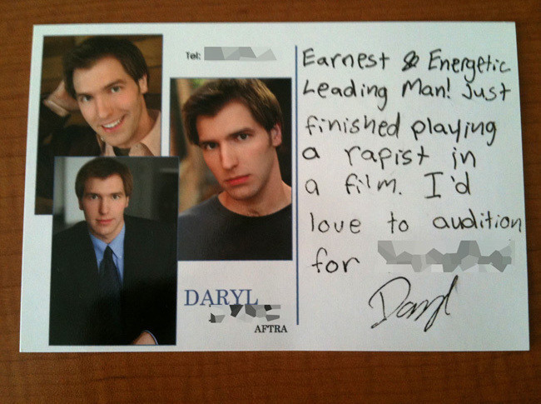

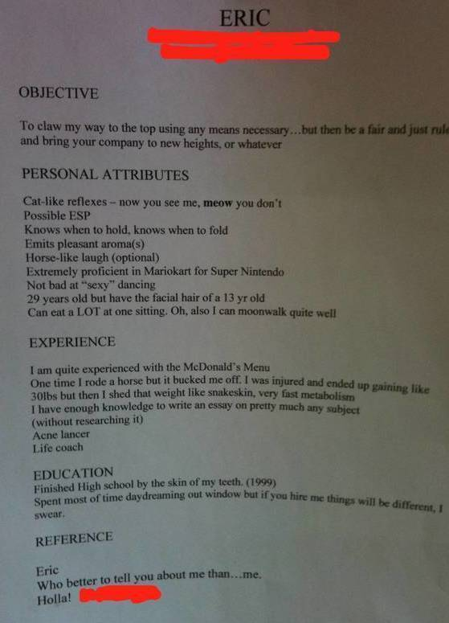

4

6

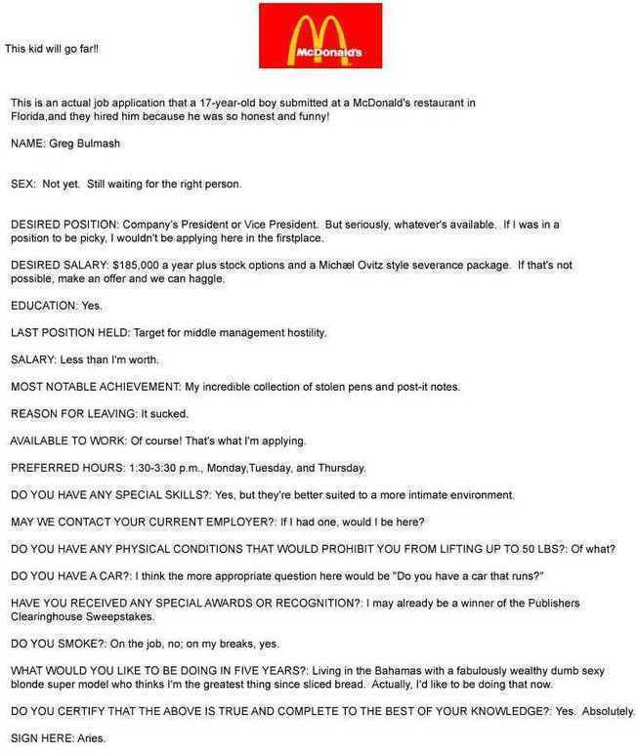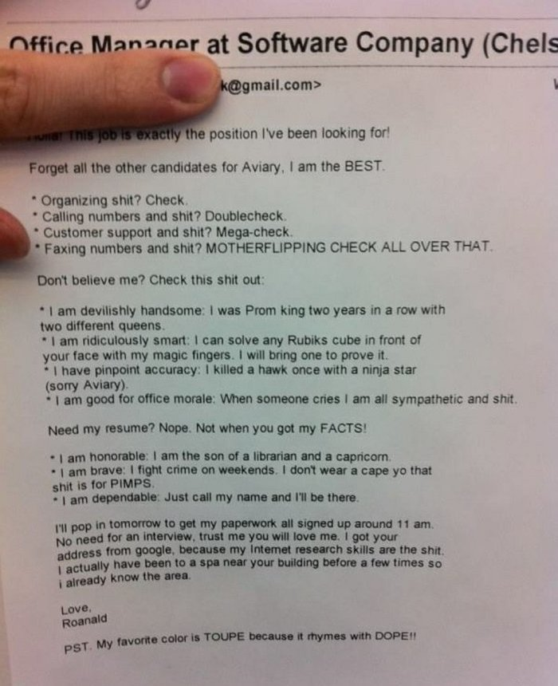

3

5

1. **FUNNY COVER LETTERS**

**Before you add humour in a cover letter, know the risks:**

* Not every job or profession dictates or needs humour, especially more serious roles in upper-level positions. However, hiring managers have the tedious task of sifting through (FR= trier) hundreds of resumes and cover letters daily. And it’s in this mundaneness that humour can truly make your cover letter shine.
* But you should also know the risks. Not every hiring manager is wired the same way. And even if they have a sense of humour, they might not have your sense of humour. Is it worth the gamble?
* **Speaking practice: “*Is the gain worth the pain?*”**
* Would you try and insert a bit of humour in your cover letter? Why (not)?
* How far can you go when it comes to humour in a cover letter?
* **Reading comprehension**: read the text below called “*The Risk Factor of Humour in a Cover Letter*”[2] and fill in this table explaining each humour style.

|  |  |
| --- | --- |
| **HUMOUR STYLE** | **EXPLANATION** |
| **The Ninja** | Because they’re applying for a “ninja position”. Working during late hours is perfect for the job. |
| **Light Humor** | You use humour but you also give your skills through this tone |
| **The Humor in Intrigue** | Very light on the humour, also tells his skill by integrating it with the jokes, makes you wants to learn more about him. |
| **The Attention Grabber With a Call to Action** | You try to catch someone’s attention through humour and you are waiting for a call. |

**While hacking your company the other day, I saw in the many files I collected that your company was looking for a cybersecurity specialist. It made me think. I’m already in your company network, I just need the job that comes along.**

**Superb Examples of Humour in a Cover Letter**

Humour comes in a wide array of styles and tastes. Chances are if you ask five people who their favourite comedian is, you’ll get five different answers. So to satisfy your curiosity for funny cover letters and the level of humour that’s been deemed acceptable for employment, here are some stellar examples of humour in a cover letter.

### **The Ninja**

Take notice of the position titles, such as the first example, which helped this applicant nail down an interview.

*Dear Potential Master,  
  
I was beyond thrilled to see the Customer Service Ninja position at [Company] for two reasons. One, I have long been a fan of your company and all the amazing work you do, and two, because as a real ninja, you can certainly understand that job opportunities for me have been few and far between since 15th-century Japan.  
  
Now, why should you consider me over substantially more well-known ninjas like Leonardo, Donatello, Michelangelo, or even Raphael? Well, for starters, I’ve been skilfully trained in the art of espionage, sabotage, infiltration, and assassination (though I would never assassinate unless ordered to, of course).  
  
Your job posting made it clear that you are looking for someone who is ready to take on a variety of responsibilities. Would it impress you to know that I’m proficient in hand-to-hand combat, the katana, and shuriken (you may know these as “ninja stars”) and know seven different ways to render a man immobile with just two fingers? In other words, I’m positive I can handle any responsibilities you throw at me. And as for thriving in a fast-paced environment: Have you ever seen a ninja fight? I’ll be fine.  
  
I noticed that the hours are from 3 p.m. to 12 a.m., which is perfect for a ninja like me since I like to operate under the cover of darkness anyway. And while I’ve been trained by the legendary Fujibayashi Nagato, one of the most legendary ninjas ever, to be self-sufficient in all my tasks, I’m very capable and enjoy working as a team while attacking.  
  
I humbly look forward to hearing from you soon and would relish the chance to come in for an interview. Maybe you’ll see me coming, maybe you won’t. A good ninja never tells.  
  
Sincerely,  
  
Applicant Name*

This applicant eventually landed the job. But for many jobs, this approach may be a bit too strong. Still, it’s a fine example of using the job title (Customer Service Ninja = <https://springprofessional.be/en/customer-engagement/job-profiles/customer-service/>) to appeal to an employer while also praising the company and showing the skills you can provide.

### **Light Humour**

In this opening line to a cover letter, the applicant applies a touch of humour but doesn’t overdo it. Then, the writer turns the humour into a skill beneficial to the position—a worthy transition that makes the cover letter stand out.

*When I was growing up, all I wanted to be was one of those people who pretend to be statues on the street. Thankfully, my career goals have become a little more aspirational over the years, but I love to draw a crowd and entertain the masses—passions that make me the perfect community manager.*

### **The Humour in Intrigue**

Another well-executed example of humour in a cover letter is just a straightforward approach that also adds a bit of intrigue. Again, the transition to the job role and mentioning how much the applicant wants to work for the company is natural, while the opening line is simple and provides a little chuckle.

*The other day, I took a career assessment, which told me I should be a maritime merchant. I’m not quite sure what that is, but it did get me thinking. A role that combines my skills in business development with my lifelong passion for the ocean would be my absolute dream. Which is how I found this role at Royal Caribbean.*

### **The Attention Grabber With a Call to Action**

Combining a great opening line with a call to action at the end, this applicant provides an insight into their life, personality, and sense of humour.

*Have you ever had your mom call five times a day asking for a status update on how your job search is going, and then sounding incredulous that not more progress has been made since the last phone call? That’s my life right now. But I’m hoping that soon my life will revolve around being your full-time social media manager. The good news is, I bring more to the table than just an overbearing mom. Let me tell you more.*

1. **ONLINE APPLICATION: The “*Indeed*” Example**

“*Indeed*” is a free website devoted to job-hunting. On this platform, you can upload a resume, program job alert emails, search for jobs, and apply for them directly. “*Indeed*” lists all the job openings from major job boards, newspapers, associations, and company career pages. Besides, employers can even post jobs directly to “*Indeed*” that may not be available anywhere else.



Browse through the “*Indeed*” website and have a look at the job applications available now.

🡪 <https://emplois.be.indeed.com/Emplois-Application>

* **“*Online Job Applications: What Happens After You Submit Your Resume*”[3] (video)**: watch the video and answer the questions below in English.

1. What does the software do with applications? Why are “keywords” so important?

Scan resume for keywords from job description. Makes matches base on certification education levels, specialization and the the matches are made

1. What is the software “not capable of”? Give some examples.

Judging your educational background quality or relevance of your skills.

1. What happens if you are a “*top candidate*”?

You are called for an interview. Every company has their own hiring process a hiring manager or recruiter might hold 10 phone interviews before bringing 5 people for an in person meeting there might even be a second or third interview before an offer is made.

1. “*Not hearing back can be tough*”: true or false? Explain either way.

True = keep at it and don’t hesitate to apply for more jobs.

1. What are the 5 things you could do while you “wait”, so that you can stay productive?

* Create a professional sounding voice mail in case you get a call from the recruiter.
* Give your references a heads up that they may be contacted
* Update your portfolio in case you are asked to provide samples of your work
* Send a follow up mail after to weeks
* Prepare answers to common interview questions

1. According to the video, to what do these numbers correspond?

|  |  |
| --- | --- |
| **1,000,000** | Millions of applications are completed on indeed every day |
| **86** | Percentage of seekers whor reported hearing back from the employer within one month |
| **10** | Number of phone calls an hiring manager might make before inviting five people for an in person interview or meeting |
| **30** | Number of online hires is incrising by 30% each year. |

1. **FINAL DEBATE**



* **Speaking exercise**: answer these questions about each topic tackled in this 4th chapter and share your opinion with the rest of the group.

1. What is the most useful tip to achieve a “*Job Search Success*”?
2. Would you dare sending a funny CV like the ones discussed earlier? Why (not)?
3. And what about sending a funny cover letter?
4. Do you think looking for a job during the COVID-19 pandemic is easier or more difficult than “normal”? Explain why.
5. What do you think of the “*Indeed*” website? Would you use it? Why (not)?



1. Source : <https://www.careeraddict.com/the-funniest-resumes-of-all-time>
2. Source (adapted from): <https://www.virtualvocations.com/blog/telecommuting-job-search-help/how-to-use-humor-in-a-cover-letter-2/>
3. Source: <https://www.youtube.com/watch?v=NTIBXS7pbBs&t=61s&ab_channel=Indeed>